The SubKiller

Meeting 1 – Oct 23th (Fri) 12:26pm to13:10pm
- Pin down an idea for project 2
- Brainstorming key features
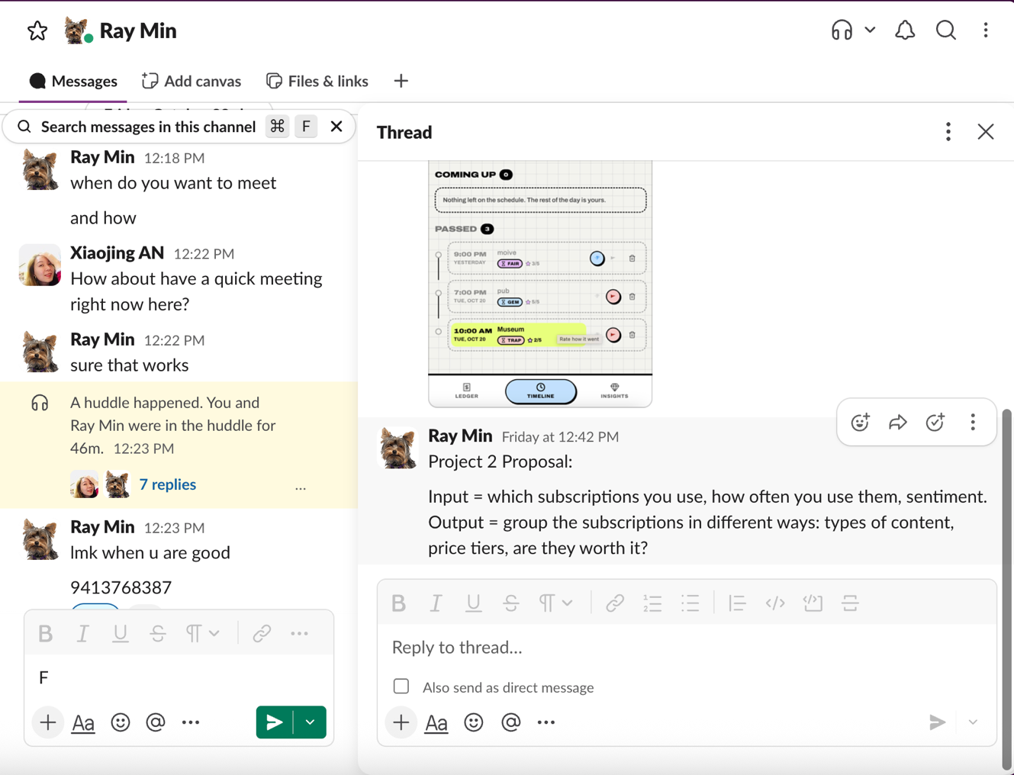

Meeting 2 – Oct 24th (Sat) 17:00 to17:52
- Decided which features need to be included
- Scheduled furture meeting time
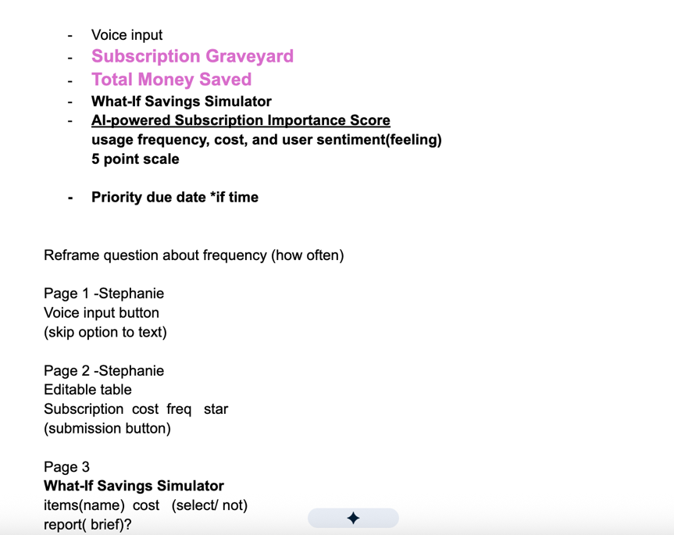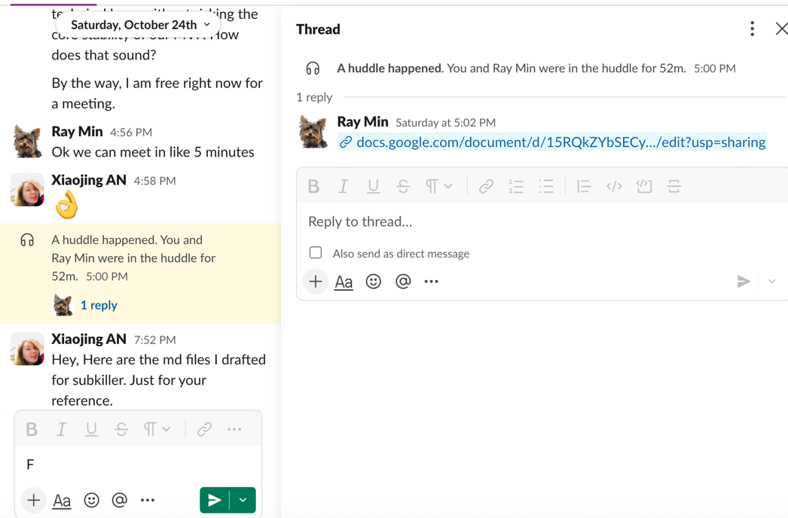

Meeting 3 Sprint Planning- Oct 26th(Mon) 8:00 pm to 8:50 pm
- Design Sprints and create issues for each sprint
- Distribute tasks
- Shcedule for future meeting
